# Goal-Based Investment Comparison

* Compare how different investments affect the probability of achieving an accumulation goal
* Demonstrate the approach using a fictional narrative loosely based on real life events
* Provide links so you can input your own goals and investment assumptions into the calculator

**The Advisor:** Jim is an investment advisor who primarily focuses on 401K plans. In addition to helping corporations select plan options, he also guides the individual investment decisions of employees. In a [previous article](https://seekingalpha.com/article/4242968-achieving-financial-freedom), he attempts to persuade Robert, a 22 year-old management consultant, not to invest all of his contributions in Emerging Markets. Specifically, Robert raises the following question: “Why should an investor not pick a diversified fund with the highest expected gain?”

**The Client:** In the aforementioned article, Robert creates his own long-term forecast for Emerging Markets as shown in Graph 1:

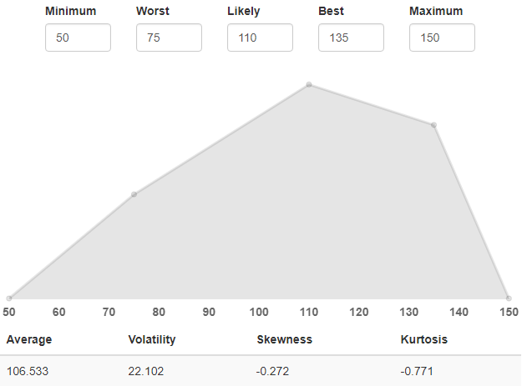

***Graph 1: Estimated annual long-term forecast for Emerging Markets assuming a current price of 100.***

He expects a gain of 6.5% in any given year with volatility of 22. Using the Probicast software, he simulates the probability of hitting his accumulation goal of $3 million over various time periods. This results in Graph 2:

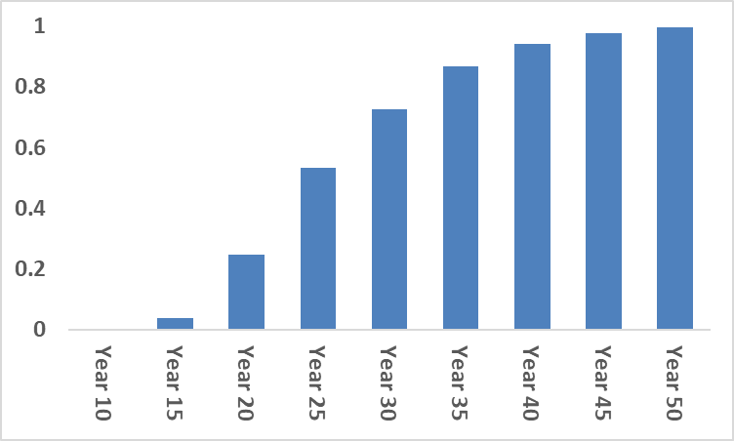

***Graph 2: Probability of accumulating $3 million over various time periods.***

Jim believes Robert’s analysis is reasonable but remains uneasy about the allocation. He wonders, “How do these results compare to simply investing in the S&P 500?”

**The Analysis:** To answer his question, Jim needs a long-term forecast for the S&P 500. He enlists the help of Chris, an investment analyst at his firm. [In another previous article](https://seekingalpha.com/article/4231891-choosing-investments-based-retirement-goals), Chris creates the forecast for the S&P 500 Index shown in Graph 3:

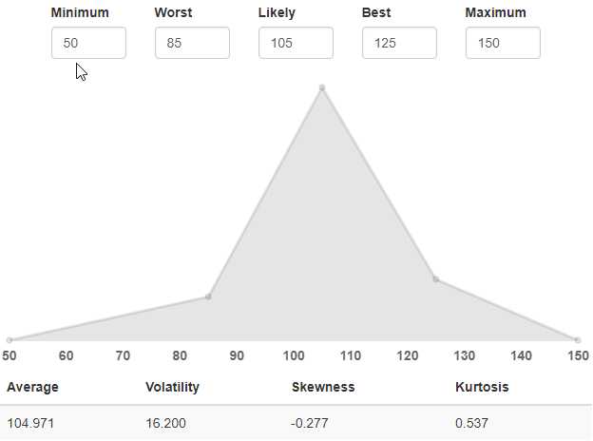

***Graph 3: Estimated annual long-term forecast for the S&P 500 Index assuming a current price of 100.***

Jim notes that the expected gain of 5% and volatility of 16.2 are both lower than for Robert’s forecast. This makes sense: the higher expected return of Emerging Markets matches its higher risk.

Next, Jim inputs both Robert’s cash flow scenarios and Chris’s forecast into the Probicast software. Graph 4 depicts the results:

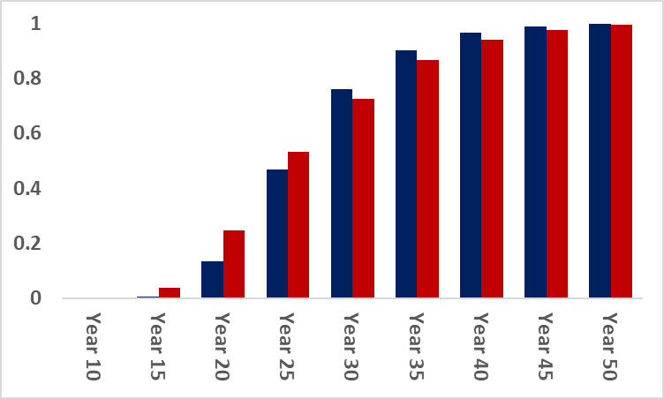

***Graph 4: Probability of accumulating $3 million over various time periods for the S&P 500 (Blue) and Emerging Markets (Red). Prior to Year 25, investing in Emerging Markets results in a higher probability of meeting the accumulation goal. Starting in Year 25, the S&P 500 delivers a superior outcome.***

Jim realizes that he must be able to explain the counterintuitive results: the higher risk-return investment seems to underperform over the long-term.

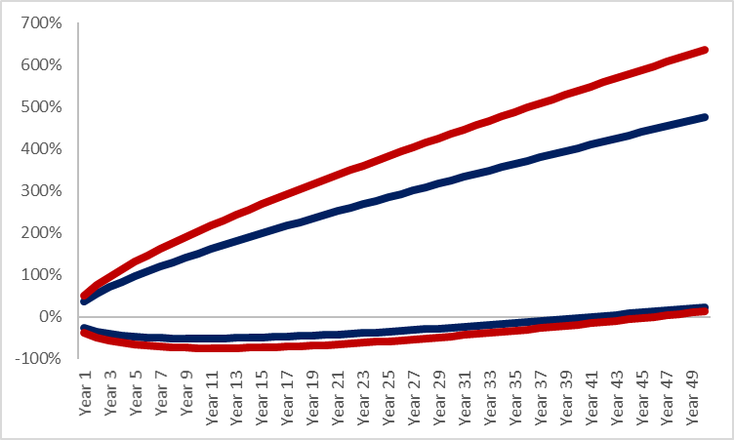

***Graph 5: Approximate 95% Confidence Intervals for the S&P 500 (Blue) and Emerging Markets (Red). Emerging Markets have a higher annual expected return than the S&P 500 (6.5% vs. 5%) but also have a higher volatility (22 vs 16). As a result, the lower bound for the S&P 500 exceeds that of Emerging Markets until Year 64 (not shown).***